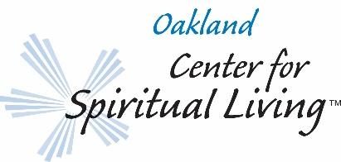
Nomination for 2021 Nonprofit Partner Return nominations to Non-Profit Partners in-box :
e-mail to Beth Van Arkel: bethvajazz@yahoo.com
PLEASE PRINT LEGIBLY OR TYPE
Deadline for nominations: Friday August 28, 2020

My nomination
Name of nonprofit organization:
Name and title of contact at organization: (e.g. Executive Director or Volunteer Coordinator):
Address: Primary contact e-mail:
Telephone: Website:
Federal ID Number:
A brief description of the work they do. (Attach brochures or newsletters if available.)
A brief description of your connection to this nonprofit organization: A personal connection or experience is required.
What qualities of God (love, joy, peace, etc) do they embody?

Information about me:
Name: OCSL member? Y N
Telephone (indicate whether day or evening):
E-mail:
A brief outline of my history with the Oakland Center for Spiritual Living:

If my nominated nonprofit organization is selected, I agree that (if needed) I will (1) attend a planning meeting, (2) assist in communication with this nonprofit organization to arrange their Sunday speaking date at the Center, and
(3) assist in hosting them on the Sunday they visit the Center.

Signed:(Congregant/Member) Date: REV.02.2020

